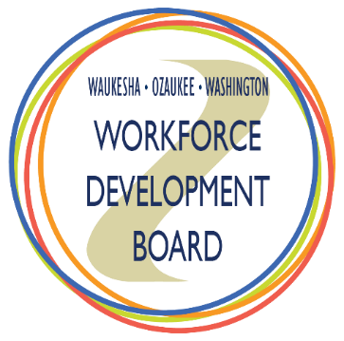
joint executive committee

agenda
Date: | Thursday, June 3, 2021
Time: | 8:00 am – 9:00 am
Location: | Virtual Meeting via Microsoft Teams  Join Microsoft Teams Meeting; Phone Number: 414-435-2078; Conference ID: 645 991 210#

# | ITEM | TIME | ACTION
1. | Call to Order and Introductions  Dawn Schicker, Chair | 8:00 am | ☐
2. | Review and Approval of Meeting Minutes  Dawn Schicker, Chair | 8:03 am | ☒
3. | Review and Approval of Draft Fiscal Year 2021-2022 Budget  Laura Catherman, WDB Director | 8:05 am | ☒
4. | Review and Approval of Service Provider Renewals for Fiscal Year 2021-2022:  - WIOA Adult and Dislocated Worker  - WIOA Youth  - Windows to Work  - Regional One-Stop Operator  Laura Catherman, WDB Director | 8:15 am | ☒
5. | Update on Strategic Projects  Laura Catherman, WDB Director | 8:25 am | ☐
6. | Update on One-Stop Operations  Beth Norris, Workforce Development Center Operations Coordinator | 8:35 am | ☐
7. | Discussion: Business and Community Trends as We Emerge from the Pandemic  All | 8:45 am | ☐
8. | Other Business  Dawn Schicker, Chair | 8:55 am | ☐

Waukesha-Ozaukee-Washington Workforce Development Board is an Equal Opportunity Program Provider. If you have a disability, need information in an alternative format, including language assistance or translation, and/or need assistance with this information, please call 262-896-8312 or call through Wisconsin Relay Service 711.

