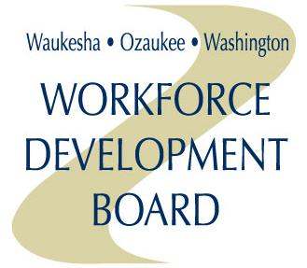
AGENDA
WORKFORCE DEVELOPMENT BOARD

Date: | Thursday, September 21, 2017 | Location: | Davians Banquet and Conference Center  N56W16300 Silver Spring Drive  Menomonee Falls, WI 53051
Time: | 11:00 a.m. | Room: | Continental West
Item # | Topic
1. | Introductions and Meeting Call to Order
2. | Welcome by County Executive Paul Farrow
3. | Approval of Minutes of the Previous Meeting
4. | Executive Report
5. | Review and Approval of Fiscal Year 2016-17 Fiscal Report
6. | Review and Approval of Revised Fiscal Year 2017-18 WIOA Budget
7. | Guest Presentations on Regional Economic Development and Workforce Development  - Jim Paetsch, Vice President – Corporate Relocation, Expansion, and Attraction, M7  - Regional Workforce Alliance: Doug Bartz, Manager, Kenosha County Workforce Development Center; Earl Buford, CEO, Employ Milwaukee; Laura Catherman, President, WOW WDB; Mark Mundl, Manager, Racine County Workforce Solutions
8. | Presentation of Employer of the Year
9. | Recognition of Former Workforce Development Board Members
10. | Election of Workforce Development Board Officers for the 2017 – 2018 Fiscal Year
11. | Other Business

Agenda items:

