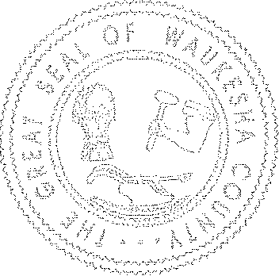
Waukesha County
COUNTY BOARD OF CANVASSERS

Revised Agenda

Tuesday, November 13, 2018 – until completed, 2018
9:00 AM
Waukesha County Administration Center, Room 155

Agenda:
- General Review of WEC January 2018 “Suggested Procedures for County Boards of Canvassers” manual

- Incorporation of any additional steps as agreed upon in Item 1 above

- New Business
  - Discuss “County-Level Post-Election Audit Options” – WEC Memorandum dated 8/1/18

  - Discuss “WEC Approves Expanded Post-Election Audits” memorandum dated 9/28/18

  - General new issue a BOC member would like to discuss.

- Start Canvass beginning first cities. Continues with towns and then villages.

- Wrap up and signing of County Certification of Results.

