It is time to provide your [**Community’s 2026 Budgeted Recycling Costs**](https://gcc02.safelinks.protection.outlook.com/?url=https%3A%2F%2Fforms.waukeshacounty.gov%2F232674618301050&data=05%7C02%7Ctripley%40waukeshacounty.gov%7C5fafb9f5dff44105007c08dde666cbd7%7Ce73e7aacbf234753b33df405529c3fb6%7C0%7C0%7C638920051396006235%7CUnknown%7CTWFpbGZsb3d8eyJFbXB0eU1hcGkiOnRydWUsIlYiOiIwLjAuMDAwMCIsIlAiOiJXaW4zMiIsIkFOIjoiTWFpbCIsIldUIjoyfQ%3D%3D%7C0%7C%7C%7C&sdata=JJS307svD0NMh97qiUV%2BSxnnR%2Ff886OAbH3WIXNQ7h4%3D&reserved=0) (Municycle) **by 4:00pm on Monday, September 15th.**

Please see below for instructions on how to complete the required forms and attachments. If you have any questions or concerns, please feel free to email [tripley@waukeshacounty.gov](mailto:tripley@waukeshacounty.gov) or call (262)-896-8013. We are committed to assisting you with submittal of this important information.

**Instructions:**

1. **Please submit your 2026 BUDGETED Recycling Costs here:** [**Municycle Recycling Costs Form**](https://gcc02.safelinks.protection.outlook.com/?url=https%3A%2F%2Fforms.waukeshacounty.gov%2F232674618301050&data=05%7C02%7Ctripley%40waukeshacounty.gov%7C5fafb9f5dff44105007c08dde666cbd7%7Ce73e7aacbf234753b33df405529c3fb6%7C0%7C0%7C638920051396023753%7CUnknown%7CTWFpbGZsb3d8eyJFbXB0eU1hcGkiOnRydWUsIlYiOiIwLjAuMDAwMCIsIlAiOiJXaW4zMiIsIkFOIjoiTWFpbCIsIldUIjoyfQ%3D%3D%7C0%7C%7C%7C&sdata=PEabv4%2FNIaprRGKU44IKZmXpsvqrwuq8rZtVjtwH27Q%3D&reserved=0). This includes all costs associated with residential hauling contract for recyclables and/or yard waste, staff time used to operate drop off centers (if recycling or yard waste is accepted) and equipment costs associated with yard waste (tub grinders, etc.)
   1. After selecting your municipality and providing your email, please download and complete the “Equipment and Staff Excel Template” (if applicable) found hyperlinked within the form.

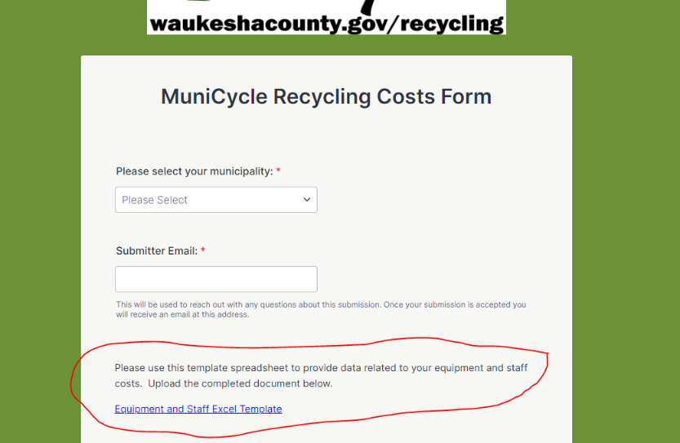

*Please note that the template includes* ***two******tabs*** *and a link to the DOT rate table. The rate table can also be found* [*HERE*](https://gcc02.safelinks.protection.outlook.com/?url=https%3A%2F%2Fdnr.wisconsin.gov%2Fsites%2Fdefault%2Ffiles%2Ftopic%2FUrbanForests%2F02-25-50_2024.pdf&data=05%7C02%7Ctripley%40waukeshacounty.gov%7C5fafb9f5dff44105007c08dde666cbd7%7Ce73e7aacbf234753b33df405529c3fb6%7C0%7C0%7C638920051396040993%7CUnknown%7CTWFpbGZsb3d8eyJFbXB0eU1hcGkiOnRydWUsIlYiOiIwLjAuMDAwMCIsIlAiOiJXaW4zMiIsIkFOIjoiTWFpbCIsIldUIjoyfQ%3D%3D%7C0%7C%7C%7C&sdata=9LCUwA2PIwQ6jASz7ANktdMi5EuNTi9e7EQaQVFJfyo%3D&reserved=0)*for your convenience.*

* 1. Upon completion of the excel template, please upload the file into the form.

* 1. Complete the other fields found in the form. If you have questions about what costs to include, please consult the posted Eligible and Ineligible Costs document.
  2. Submit the form. Upon submittal, you will receive an email confirmation as receipt.

**We ask that entries for Municycle be completed no later than 4:00 PM on Monday, September 15th**.

Thank you for your time and attention.

Respectfully,