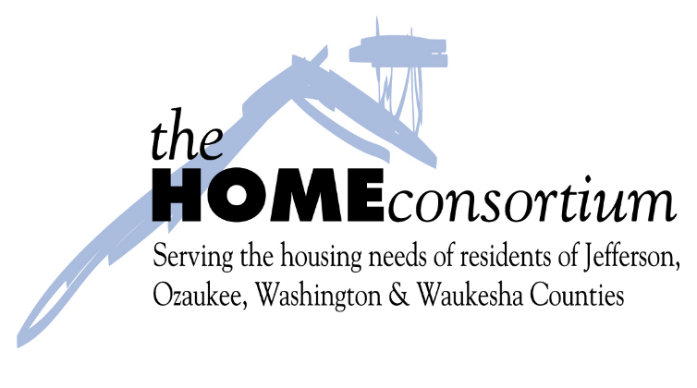
DOWN PAYMENT ASSISTANCE FORGIVABLE LOAN PROGRAM
COMMON ITEMS FOUND ON A DOWNPAYMENT ASSISTANCE (DPA) INSPECTION
The HOME Consortium cannot provide DPA funding to a home buyer if the home they hope to purchase does not pass the HOME Consortium code inspection. To help expedite the inspection and closing process below is a list of common items found on a DPA inspection which cause the house to fail the inspection.
This list should be provided to the current homeowner and/or realtor to ensure these items are handled prior to the inspection taking place.
1. Electrical wires exposed, missing cover plates on outlets and missing junction box covers.
2. Smoke detectors missing or not working. One needed on every level.
3. Carbon monoxide detector missing or not working. One needed on lowest livable level.
4. Handrails missing or incomplete. Needed where 3 or more stairs are present.
5. GFCI issues – outlet won’t trip.
6. Cracked windowpanes
7. Leaky faucets
8. Improper use of extension cords, typically for water softeners. Needs dedicated outlet.
9. Missing or torn shingles
10.Inoperable windows – one most open in each room and all must lock if within 6’ of ground.
11.Chipping or peeling paint or stain on homes built before 1978 will require lead testing. If positive for lead, remediation or abatement will be required.
If you have any questions, please contact Debbie Narus at 262-896-8170 or dnarus@waukeshacounty.gov

