(Sample) Stormwater Management Practice Maintenance Agreement

Document Number
Name and Return Address

[Owners Name], as “Owner” of the property described below, in accordance with Chapter 14 Waukesha County Code of Ordinances, agrees to install and maintain stormwater management practice(s) on the subject property in accordance with approved plans and Stormwater Permit conditions. The owner further agrees to the terms stated in this document to ensure that the stormwater management practice(s) continues serving the intended functions in perpetuity. This Agreement includes the following exhibits:

Exhibit A: Legal Description of the real estate for which this Agreement applies (“Property”).
Exhibit B: Location Map(s) – shows an accurate location of each stormwater management practice affected by this Agreement.
Exhibit C: Maintenance Plan – prescribes those activities that must be carried out to maintain compliance with this Agreement.

Note: After construction verification has been accepted by Waukesha County for all planned stormwater management practices, an addendum(s) to this agreement shall be recorded by the Owner showing design and construction details. The addendum may contain several additional exhibits.
Land Resources Division
515 W Moreland Blvd, Rm AC260
Waukesha, WI 53188

Through this Agreement, the Owner hereby subjects the Property to the following covenants, conditions and restrictions:

____________________________________ Parcel Identification Number(s) – (PIN)

- The Owner shall be responsible for the routine and extraordinary maintenance and repair of the stormwater management practice(s) and drainage easements identified in Exhibit B in accordance with the maintenance plan contained in Exhibit C.
- Upon written notification by Town of _________ or their designee, the Owner(s) shall, at their own cost and within a reasonable time period determined by the Town of _________, have an inspection of the stormwater management practice conducted by a qualified professional, file a report with the Town of _________ and complete any maintenance or repair work recommended in the report. The Owner(s) shall be liable for the failure to undertake any maintenance or repairs.
- In addition, and independent of the requirements under paragraph 2 above, the Town of _________, or its designee, is authorized to access the property as necessary to conduct inspections of the stormwater management practices or drainage easements to ascertain compliance with the intent of this Agreement and the activities prescribed in Exhibit C. The Town of _________ may require work to be done which differs from the report described in paragraph 2 above, if the Town of _________ reasonably concludes that such work is necessary and consistent with the intent of this agreement. Upon notification by the Town of _________ of required maintenance or repairs, the Owner(s) shall complete the specified maintenance or repairs within a reasonable time frame determined by the Town of _________.
- If the Owner(s) do not complete an inspection under 2 above or required maintenance or repairs under 3. above within the specified time period, the Town of _________ is authorized, but not required, to perform the specified inspections, maintenance or repairs. In the case of an emergency situation, as determined by the Town of _________, no notice shall be required prior to the Town of _________ performing emergency maintenance or repairs. The Town of _________ may levy the costs and expenses of such inspections, maintenance or repair related actions as a special charge against the Property and collected as such in accordance with the procedures under s. 66.0627 Wis. Stats. or subch. VII of ch. 66 Wis. Stats.
- This Agreement shall run with the Property and be binding upon all heirs, successors and assigns. After the Owner records the addendum noted above, the Town of _________ shall have the sole authority to modify this agreement upon a 30-day notice to the current Owner(s).

Dated this ___ day of ____________, 20__.

Owner:

____________________________________________
(Owners Signature)

(Owners Typed Name)

Acknowledgements

State of Wisconsin:
County of Waukesha

Personally came before me this day of , 20__, the above named ___[Owners name]_____ to me known to be the person who executed the foregoing instrument and acknowledged the same.

.
[Name]
Notary Public, Waukesha County, WI
My commission expires: .

For Certification Stamp

This document was drafted by:

[Name and address of drafter]

(Sample)
Exhibit A – Legal Description

The following description and reduced copy map identifies the land parcel(s) affected by this Agreement. For a larger scale view of the referenced document, contact the Waukesha County Register of Deeds office.

Date of Recording: [date.]
Map Produced By: [designer’s name.]
Legal Description: [enter legal description as described on the property title here.]

Survey map of property showing legal boundaries.

N
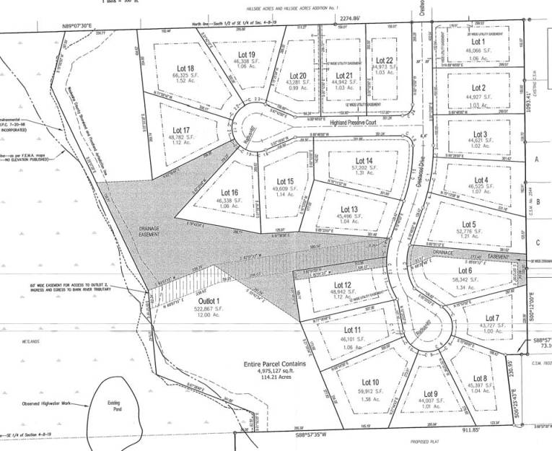
(Sample)
Drainage Easement Restrictions: Shaded area on map indicates a drainage easement for stormwater collection, conveyance and treatment. No buildings or other structures are allowed in these areas. No grading or filling is allowed that may interrupt stormwater flows in any way. See Exhibit C for specific maintenance requirements for stormwater management practices within this area. See Exhibit B for details on location.

Exhibit B - Location Map
Stormwater Management Practices Covered by this Agreement

[An example location map and the minimum elements that must accompany the map are shown below. This exhibit must be customized for each site. Map scale must be sufficiently large enough to show necessary details.]

The stormwater management practices covered by this Agreement are depicted in the reduced copy of a portion of the construction plans, as shown below. All of the noted stormwater management practices are located within a drainage easement, as noted in Exhibit A.

Stormwater Practices: [brief list]
Location of Practices: [enter a metes and bounds description of the easement area. The figure below must illustrate this description.]

Figure 1
Plan View of StormwaterPractices

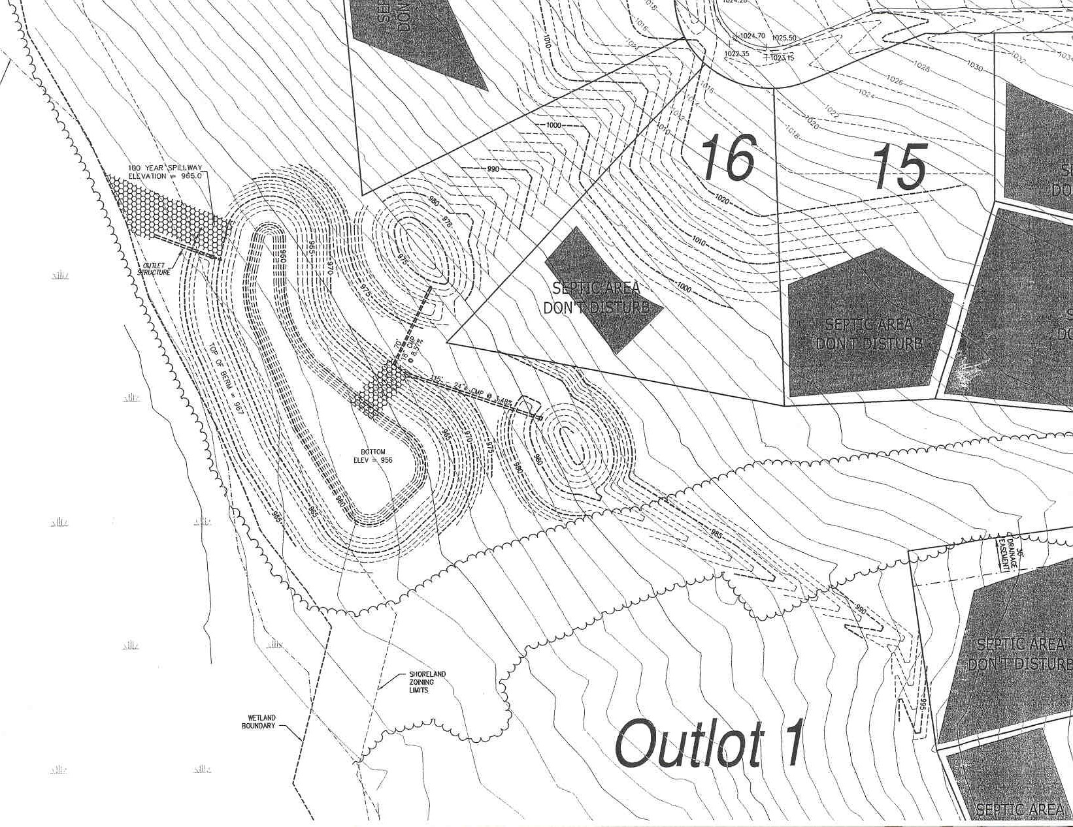
(Sample)
Access Lane (15 feet wide)

N
Grass Swales (2)
Wet Detention Basin #1
Forebays (2)
Exhibit C
Stormwater Practice Maintenance Plan

This exhibit explains the basic function of each of the stormwater practices listed in Exhibit B and prescribes the minimum maintenance requirements to remain compliant with this Agreement. The maintenance activities listed below are aimed to ensure these practices continue serving their intended functions in perpetuity. The list of activities is not all inclusive, but rather indicates the minimum type of maintenance that can be expected for this particular site. Access to the stormwater practices for maintenance vehicles is shown in Exhibit B. Any failure of a stormwaterpractice that is caused by a lack of maintenance will subject the Owner(s) to enforcement of the provisions listed on page 1 of this Agreement by the Town of _________.

System Description:
[ include a description of the drainage area and the installed stormwater management system & best management practices.]

“As-built” construction drawings of the basin, showing actual dimensions, elevations, outlet structures, etc. will be recorded as an addendum(s) to this agreement within 60 days after Waukesha County accepts verification of construction from the project engineer.

Minimum Maintenance Requirements:
To ensure the proper long-term function of the stormwater management practices described above, the following activities must be completed:
- All outlet pipes must be checked monthly to ensure there is no blockage from floating debris or ice, especially the washed stone in front of the 3-inch orifice and the trash rack on the riser in the main basin. Any blockage must be removed immediately. The washed stone must be replaced when it becomes clogged.
- Grass swales shall be preserved to allow free flowing of surface runoff in accordance with approved grading plans. No buildings or other structures are allowed in these areas. No grading or filling is allowed that may interrupt flows in any way.
- Grass swales, inlets and outlets must be checked after heavy rains (minimum of annually) for signs of erosion. Any eroding areas must be repaired immediately to prevent premature sediment build-up in the downstream forebays or basin. Erosion matting is recommended for repairing grassed areas.
- NO trees are to be planted or allowed to grow on the earthen berms. Tree root systems can reduce soil compaction and cause berm failure. The berms must be inspected annually and any woody vegetation removed.
- Invasive plant and animal species shall be managed in compliance with Wisconsin Administrative Code Chapter NR 40. This may require eradication of invasive species in some cases.
- If the permanent pool falls below the safety shelf, a review shall be performed to determine whether the cause is liner leakage or an insufficient water budget. If the cause is leakage, the liner shall be repaired. Leakage due to muskrat burrows may require removal of the animals, repair of the liner with clay, and embedding wire mesh in the liner to deter further burrowing. If the permanent pool cannot be sustained at the design elevation, benching of the safety shelf may be necessary.
- If floating algae or weed growth becomes a nuisance (decay odors, etc.), it must be removed from the basin or the forebay and deposited where it cannot drain back into the basin. Removal of the vegetation from the water reduces regrowth the following season (by harvesting the nutrients). Wetland vegetation must be maintained along the waters edge for safety and pollutant removal purposes.
- If mosquitoes become a nuisance, the use of mosquito larvicide containing naturally-occurring Bti soil bacteria is recommended.
- When sediment in the forebays or the basin has accumulated to an elevation of three feet below the outlet elevation, it must be removed (see Exhibit D). All removed sediment must be placed in an appropriate upland disposal site and stabilized (grass cover) to prevent sediment from washing back into the basin. The forebays will likely need sediment removal first. Failure to remove sediment from the forebays will cause resuspension of previously trapped sediments and increase downstream deposition.
- No grading or filling of the basin or berm other than for sediment removal is allowed, unless otherwise approved by the Town of _________.
- Periodic mowing of the grass swales will encourage vigorous grass cover and allow better inspections for erosion. Waiting until after August 1 will avoid disturbing nesting wildlife. Mowing around the basin or the forebays may attract nuisance populations of geese to the property and is not necessary or recommended.
- Any other repair or maintenance needed to ensure the continued function of the stormwater practices or as ordered by the Town of _________ under the provisions listed on page 1 of this Agreement.
- Aerators/Fountains – If an aerator or fountain is desired for visual and other aesthetic effects (aerators designed to mix the contents of the pond are prohibited) they must meet all of the items below:
    - Use an aerator/fountain that does not have a depth of influence that extends into the sediment storage depth (i.e. more than three feet below the normal water surface).
    - If the water surface drops due to drought or leakage, the aerator / fountain may not be operated until the water rises enough for the depth of influence to be above the sediment storage layer. Therefore, if the depth of influence of the aerator / fountain is two feet, the water surface must be within one foot or less of the lowest pond outlet.
    - Provide an automatic shut-off of the aerator/fountain as the pond starts to rise during a storm event. The aerator/fountain must remain off while the pond depth returns to the permanent pool elevation and, further, shall remain off for an additional 48 hours, as required for the design micron particle size to settle to below the draw depth of the pump.
    - Configure the pump intake to draw water primarily from a horizontal plane so as to minimize the creation of a circulatory pattern from bottom to top throughout the pond.

[Note: Other examples of maintenance plans for infiltration practices are available from Waukesha County.]

Land Resources Division
515 W Moreland Blvd, Rm AC260
Waukesha, WI 53188
Document number
Addendum 1 (Sample)
Stormwater Management Practice Maintenance Agreement

Name and Return Address

____________________________________ Parcel Identification Number(s) – (PIN)

The purpose of this addendum is to record verified “as-built” construction details, supporting design data and permit termination documentation for the stormwater management practice(s) located on [enter legal description as described on the property title here.]Waukesha County, Wisconsin. This document shall serve as an addendum to document # _____________, herein referred to as the “Maintenance Agreement”. This addendum includes all of the following exhibits:

Exhibit D: Design Summary – contains a summary of key engineering calculations and other data used to design the wet detention basin.
Exhibit E: As-built Survey – shows detailed “as-built” cross-section and plan view of the wet detention basin.
Exhibit F: Engineering/Construction Verification – provides verification from the project engineer that the design and construction of the wet detention basin complies with all applicable technical standards and Waukesha County ordinance requirements.

Dated this ___ day of ____________, 20__.

Owner:
____________________________________________
[Owners Signature – per the Maintenance Agreement]

____________________________________________
[Owners Typed Name]
Acknowledgements

State of Wisconsin County of Waukesha

Personally came before me this day of , 20__, the above named ___[Owners name]_____ to me known to be the person who executed the foregoing
instrument and acknowledged the same.

For Certification Stamp

.
[Name]
Notary Public, Waukesha County, WI
My commission expires: .

This document was drafted by:

____________________________

____________________________

[Name and address of drafter]
(Sample)
Exhibit D
Design Summaries for Wet Detention Basin #1

Project Identifier: Highland Preserve Subdivision Project Size: 40 Acres No. of Lots: 22

Number of Runoff Discharge Points: 1 Watershed (ultimate discharge): Pewaukee Lake

Watershed Area (including off-site runoff traveling through project area): 67 acres (26 acres off-site)

Watershed Data Summary. The following table summarizes the watershed data used to determine peak flows and runoff volumes required to design wet detention basin #1.

Summary Data Elements | Subwatershed A |  | Subwatershed B (off-site)
 | Pre-develop | Post-develop | Pre-develop | Post-develop
Watershed Areas (in acres)  (see attached map) | 41 acres | 41 acres | 26 | 26
Average Watershed Slopes (%) | 2-8% | 2-8% | 3-6% | 3-6%
Land Uses (% of each)  (see attached map) | 75 ac. cropland  15 ac. brush  10 ac. woodland | 110 ac. ½ ac. lots  5ac. brush  5 ac. woodlands | 50% cropland  50% 1 acre lots | 50% cropland  50% 1 acre lots
Runoff Curve Numbers | 68 x 75ac.= 5100  30 x 25ac.= 750  Net 5850\100 ac.  RCN = 59 | 70 x 110 ac.= 7700  10 x 10 ac.= 100  Net 7800\120ac  RCN = 65 | RCN = 68  (state standard) | RCN = 70
Conveyance Systems Types | Grass waterway | 50% grass swale  50% storm sewer | 100% bare channel | 100% grass swale
Summary of Average Conveyance System Data | 8’ bottom/4:1 ss  2’ depth/3% grade | 2’ depth swale/3%  30” r/c sewer/2%  (see calcs.) | 15’ (w) top  1’ (d) parabolic  2% grade | 2’ deep standard road ditch  2% grade
Time of Concentration (Tc)  (see attached map & worksheets) | 1.1 hrs. | .97 hrs. | .74 hrs. | .65 hrs.
25% of 2-yr 24-hr post-dev runoff volume | N/A | 2.29 ac. ft. | N/A | .19 ac. ft.
1-yr. /24 hour Peak Flow  (see attached hydrographs) | 2.3 cfs | 5.1 cfs | 1.9 cfs | 2.9 cfs
2-yr./24 hour Peak Flow | 11.2 cfs | 14.3 cfs | 5.1 cfs | 3.2 cfs
10-yr./24 hour Peak Flow | 21 cfs | 32 cfs | 18.4 cfs | 11.3 cfs
100-yr./24 hour Peak Flow | 78 cfs | 91 cfs | 53 cfs | 21 cfs

Exhibit D (continued)

Practice Design Summary. The following table summarizes the data used to design wet detention basin #1.

Design Element |  |  |  | Design Data
Site assessment data: (see attached maps)
Contributing drainage area to basin (subwatershed A & B) |  |  |  | 70 acres
Distance to nearest private well (including off-site wells) |  |  |  | > 100 feet
Distance to municipal well (including off-site wells) |  |  |  | > 1200 feet
Wellhead protection area involved? |  |  |  | No
Ground slope at site of proposed basin |  |  |  | average 3%
Any buried or overhead utilities in the area? |  |  |  | No
Proposed outfall conveyance system/discharge (w/ distances) |  |  |  | 35 ft. to CTH “U” Road ditch  1000 ft. to wetland
Any downstream roads or other structures? (describe) |  |  |  | Yes – 36” CMP road culvert
Floodplain, shoreland or wetlands? |  |  |  | No
Soil investigation data (see attached map & soil logs):
Number of soil investigations completed |  |  |  | 3 (in basin area)
Do elevations of test holes extend 3 ft. below proposed bottom? |  |  |  | Yes (see map)
Average soil texture at pond bottom elevation (USDA) |  |  |  | Clay loam
Distance from pond bottom to bedrock |  |  |  | > 5 feet
Distance from pond bottom to seasonal water table |  |  |  | Pond bottom 2 ft. below mottling  No water observed in test holes
General basin design data (see attached detailed drawings):
Permanent pool surface area |  |  |  | 1.5 acres
Design permanent pool water surface elevation |  |  |  | elev. 900.0
Top of berm elevation (after settling) and width |  |  |  | elev. 905.0 / 10 feet wide
Length/width (dimensions/ratio) |  |  |  | 445 ft. (L) x 145 ft. (W) = 3:1
Safety shelf design (length, grade, max. depth) |  |  |  | 10 ft. @ 10% slope/1.5’ deepest
Ave. water depth (minus safety shelf/sediment) |  |  |  | 5 ft. (in center)
Sediment forebay size & depth |  |  |  | .16 acres (13% pool size)/5 feet
Sediment storage depth & design maintenance |  |  |  | 2 ft. depth for forebay & pool  15 year maintenance schedule

Design Basin Inflow, Outflow & Storage Data
(see attached hydrographs and detail drawings)
Inflow Peak/Volume | Maximum  Outflow Rate | Max. Water Elevation | Storage Volume  at Max. Elev.  (above perm. pool) |  | Outflow Control Structures*
6.8 cfs  (1-yr./24 hr. peak) | .7 cfs  (34 hr. drawdown) | 901.3 ft. | 2 acre feet |  | #1
24.3 cfs  (Post 2-yr./24 hr. peak) | 11 cfs | 902.0 ft. | 3.1 acre feet |  | #1 and #2
72 cfs  (Post 10-yr./24 hr. peak) | 35 cfs | 903.0 ft. | 4.5 acre feet |  | #3
171 cfs  (Post 100-yr./24 hr. peak) | 143 cfs | 904.0 ft. | 6.0 acre feet |  | #3 and #4
* #1 = 6 inch orifice in water level control weir plate – flow line elev. @ 900.0 (1.3 ft. max. head)
#2 = 2 foot wide rectangular weir – flow line elev. @ 901.3 (.7 ft. hydraulic head)
#3 = 30 inch diameter smooth wall pvc pipe – flow line elev. @ 900.0 (3.0 ft. max. hydraulic head)
#4 = 30 foot wide earthen/grass emergency spillway – flow line elev. @ 903.0 (1.0 ft. max. depth)

Exhibit D (continued)

Watershed Map. The watershed map shown below was used to determine the post-development data contained in this exhibit. The post-developed watershed areas are the same as the pre-development watershed areas for this project.

[Map scale must be sufficiently large enough to show necessary details, but page size should not exceed 11” x 17”.]

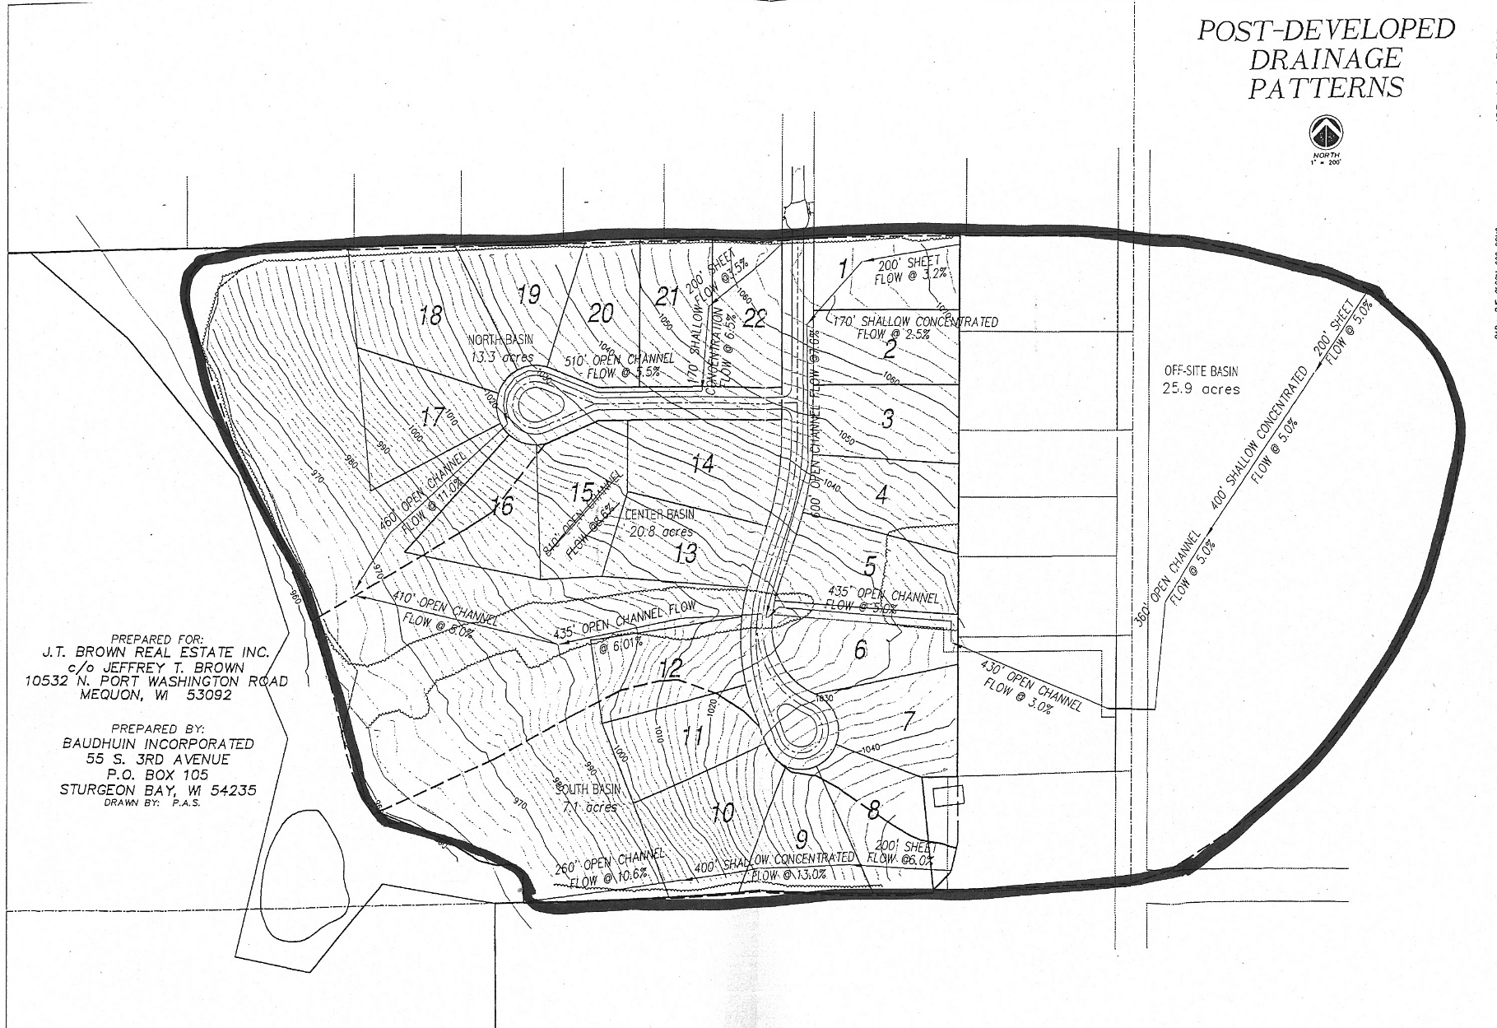
(Sample)
Exhibit E
As-built Survey for Wet Detention Basin #1

The wet detention basin depicted in Figure 1 is a reduced copy of the as-built plan.

StormwaterPractice: Wet Detention Basin #1
Location of Practice: [ enter a metes and bounds description of the easement area.]

Cross-Section A – A’
[Note: Show plan view of BMP with cross-section location clearly labeled and cross-referenced. On cross-section and plan view, clearly label all key components and elevations of the BMP. Also show outlet details. Map scale must be sufficiently large enough to show necessary details, but page size should not exceed 11” x 17”.]

Figure 2
Elevation = 962.5
(normal water/outlet elevation)
Elevation = 956.0
(bottom of pond)
Elevation = 959.5
(sediment removal)

Figure 3
Outlet Structure Detail
Elevation = 967.0

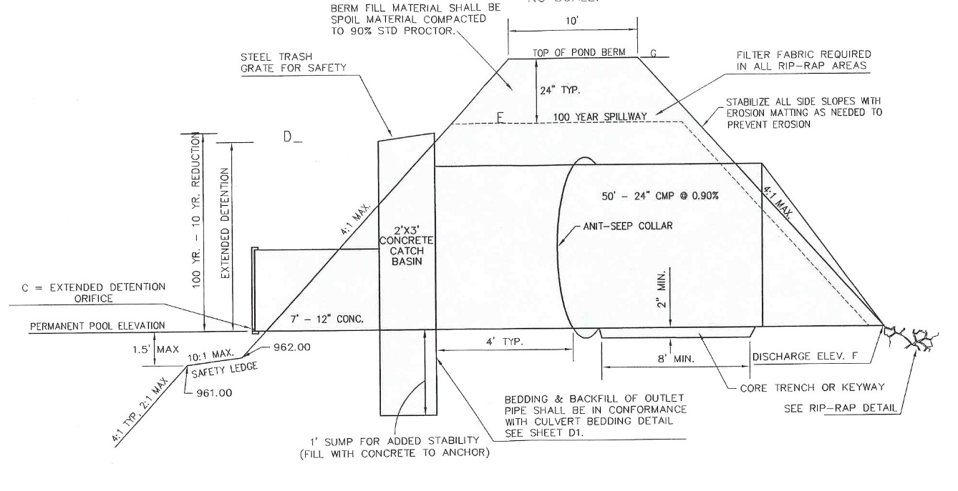
Exhibit “F”
Elevation = 965.0
(rock lined chute)
Elevation = 962.5
(Bottom of 3” hole, covered with stone)
Elevation = 964.5

Engineering/Construction Verification

DATE: ______________________

TO: Land Resources Division
Waukesha County Department of Parks and Land Use

FROM: __________________________________________[Project Engineer’s Name/Company]

RE: Engineering/Construction Verification for the following project:
Project Name: ________________________________________
Section _________________, Town of ____________________
Stormwater Permit # ________________________
Stormwater Management Practices: ________________________________________
_______________________________________________________________________

For the above-referenced project and stormwater management practices, this correspondence shall serve as verification that: 1) all site inspections outlined in approved inspection plans have been successfully completed; and 2) the stormwater management practice design data presented in Exhibit D, and the “as-built” construction documentation presented in Exhibit E comply with all applicable state and local technical standards, in accordance with the Waukesha County Stormwater Management and Erosion Control Ordinance.

[Must include one of the following two statements:]

1. Any variations from the originally approved construction plans are noted in Exhibit E. These variations are considered to be within the tolerances of standard construction techniques and do not affect the original design as presented in Exhibit D in any way.
[Note: The County may request additional documentation to support this statement depending on the extent of deviations from the approved plans.]

Or

2. Any design or construction changes from the originally approved construction plans are documented in Exhibits D and E and have been approved by Waukesha County.

[Note: If warm season and wetland planting verification is required, it may be included in this exhibit.]
(Signed P.E. stamp must be included)

